Full Stack Development with MERN Project Documentation format

# Introduction

* **Project Title:** **OrderOnTheGo - SB Foods**
* **Team Members:**

**1.Team Leader :** **Bhavya Tatineni**

Coordinator

Builds RESTful APIs using Node.js and Express.js, manages authentication and server logic.

**2.Team member :** **Bande Raveendra**

Works on the React-based UI, handles component design, page routing, and user interactions.

**3. Team member :** **Bandreddi Mahitha**

Designs and manages MongoDB schemas, handles CRUD operations and ensures data consistency.

**4.Team member :** **Banala Lahari**

Responsible for overall planning, coordination, GitHub management, and integration of frontend and backend.

# Project Overview

#### **Project Purpose: OrderOnTheGo – SB Foods**

#### The OrderOnTheGo – SB Foods project is a full-stack web application developed to streamline and enhance the online food ordering experience. The primary objective is to deliver a modern, user-friendly platform that allows customers to conveniently browse, select, and order food items from various restaurants through a responsive web interface.

#### Key goals of the application include:

#### Enabling users to access and explore food menus at any time.

#### Allowing customers to add items to a cart and place orders efficiently.

#### Reducing the dependency on physical visits or phone calls to restaurants.

#### Providing a robust backend system for managing products, orders, and user data.

#### The project aims to emulate the essential functionalities of popular food delivery platforms such as Swiggy, Zomato, and Uber Eats, utilizing open-source technologies to ensure flexibility, scalability, and ease of deployment.

#### **Features: For Users:**

* **Sign Up / Log In** – Create an account and access your orders.
* **Browse Food Items** – View a list of available dishes with images, prices, and descriptions.
* **Add to Cart** – Add favorite food items to your cart.
* **Cart Storage** – Your cart items are saved even if you refresh the page.
* **Place Orders** – Enter your address and choose payment method to place an order.
* **Order Confirmation** – Get a message when your order is successfully placed.

#### **For Admin (Future Scope):**

* **Add or Update Products** – Admin can manage food items.
* **View Orders** – Admin can see orders placed by users.

# Architecture

### **Frontend (React.js)**

* Built using React with multiple pages (Home, Products, Cart, etc.)
* Uses React Router for navigation and Context API for managing the cart
* Axios is used for API calls to the backend
* Cart and user info are stored in localStorage

### **Backend (Node.js + Express.js)**

* Handles API routes like register, login, get products, and place orders
* Uses Express middleware for JSON handling and CORS
* Connects to MongoDB using Mongoose

### **Database (MongoDB)**

* Stores user, product, and order data
* Collections:
  + users: name, email, password, address
  + products: name, description, price, image
  + orders: userId, items, address, payment method

# Setup Instructions

### Prerequisites

* **Node.js & npm** – For running frontend and backend
* **MongoDB** – Local database (use Compass or terminal)
* **Git** – To clone the project
* **VS Code** – Recommended editor

### Installation Steps

**Clone the Project**

git clone https://github.com/srikanthramagani/OrderGo.git

cd OrderGo

1. **Install & Run Backend**

cd server

npm install

node server.js

1. **Install & Run Frontend**  
   Open a new terminal:

cd client

npm install

npm start

1. **Start MongoDB**
   * Use MongoDB Compass or run mongod in terminal.

Your app will run at:

* Frontend: http://localhost:3000
* Backend API: http://localhost:5000

# Folder Structure

* + **Client(React frontend):**

client/

├── public/ → Static assets

├── src/

│ ├── components/

│ │ └── pages/ → All page components (Home, Cart, Login, etc.)

│ ├── context/ → Cart context (global state)

│ ├── App.jsx → Main component with routes

│ └── index.js → Entry point of the app

* + **Server(Node.js backend):**

server/

├── models/ → Mongoose schemas (User, Product, Order)

├── server.js → Main Express server file

# Running the Application

### **Frontend :**

cd client

npm start

Runs the React app at: http://localhost:3000

### **Backend :**

cd server

npm start # Or use: node server.js

Runs the Node.js server at: http://localhost:5000

# API Documentation

### **POST /api/register : Registers a new user.**

### **POST /api/login** : **Logs in an existing user.**

### **GET /api/products** : **Retrieves a list of available food products.**

### **POST /api/orders** : **Places a new order.**

# Authentication

### How Authentication Works:

* Users register by providing their name, email, password, and address using the endpoint:

POST /api/register

* They log in with their email and password using:

POST /api/login

### Method Used:

* The current setup uses **basic email and password matching**.
* There is **no token-based authentication** or sessions implemented at this stage.
* After login, the user’s details can be stored on the frontend (e.g., in localStorage) to maintain the login state.

### Recommendations for Improvement:

To enhance security in the future, it is recommended to:

* Implement **JWT (JSON Web Token)** authentication.
* Use **middleware** to protect private API routes.
* Store tokens securely (e.g., in localStorage or HTTP-only cookies).

# User Interface

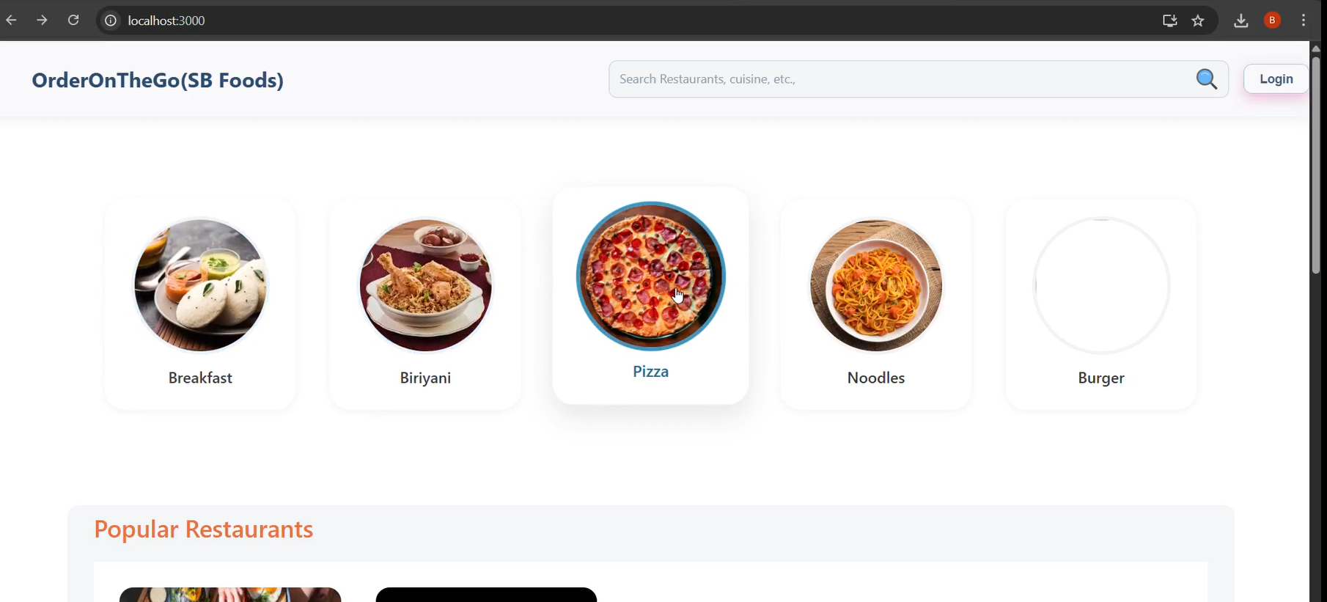

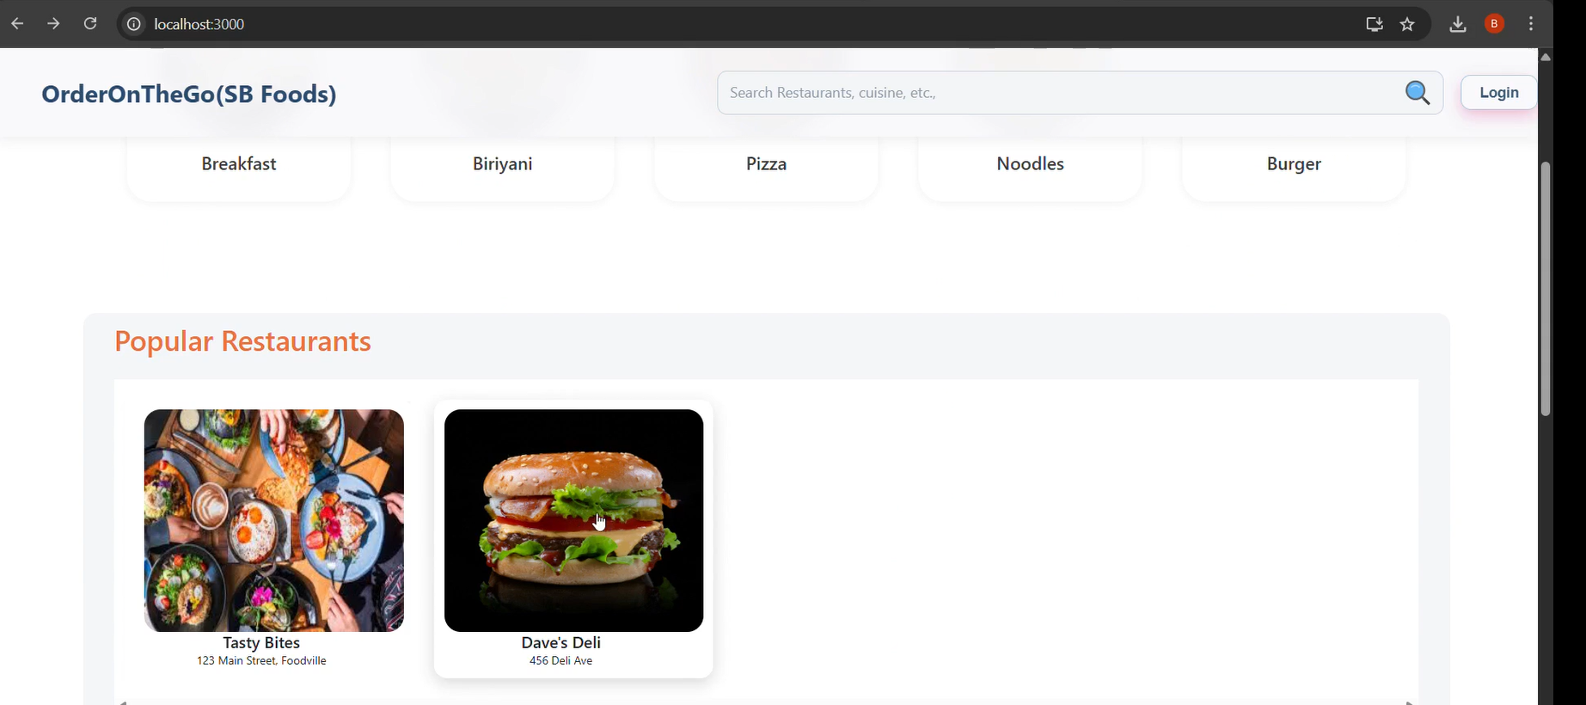

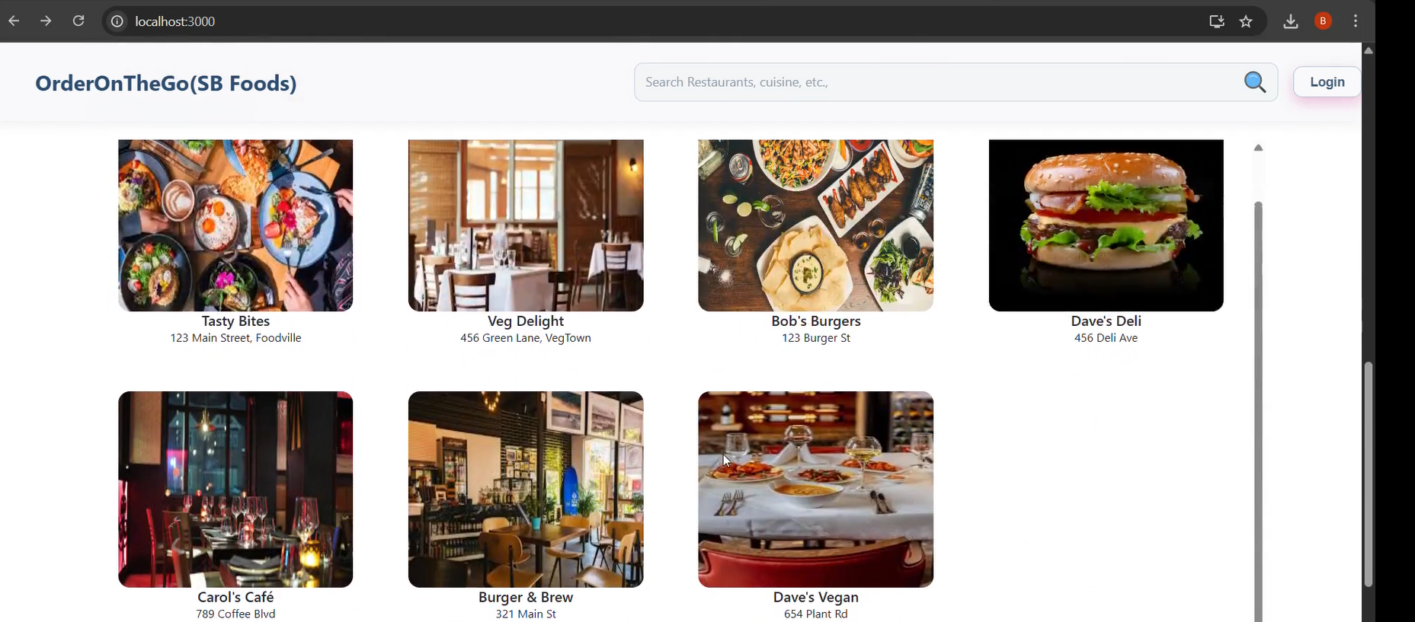

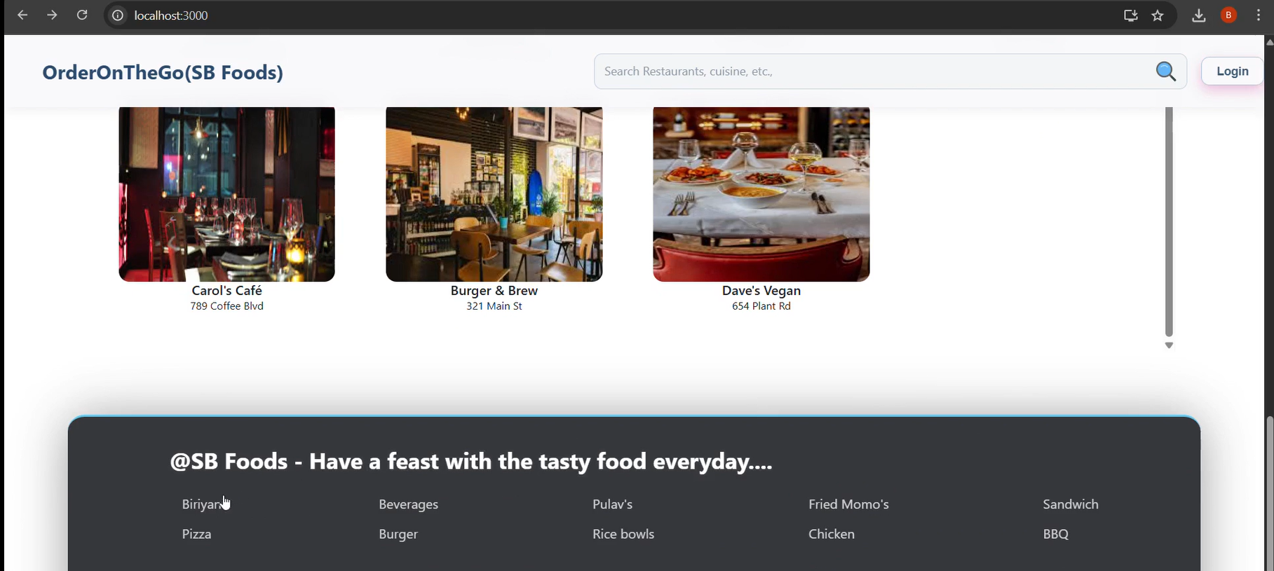

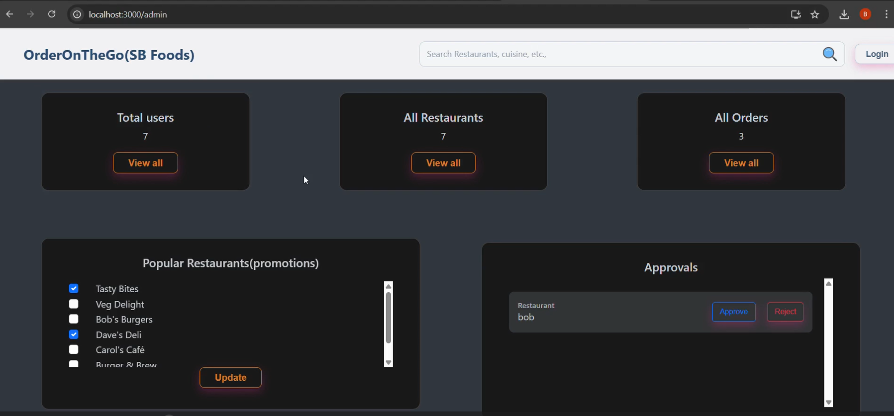

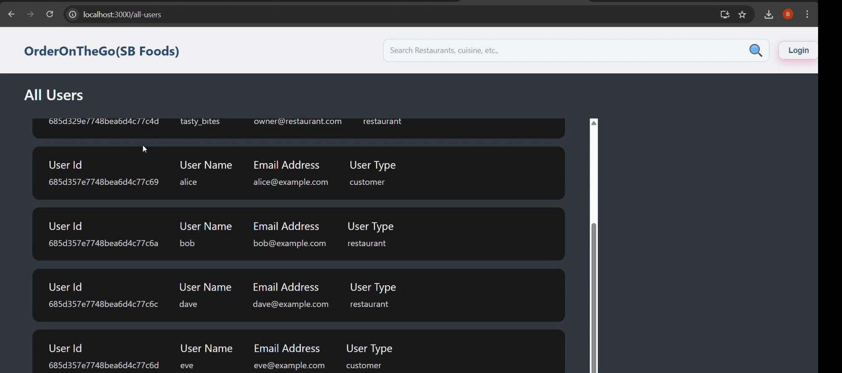

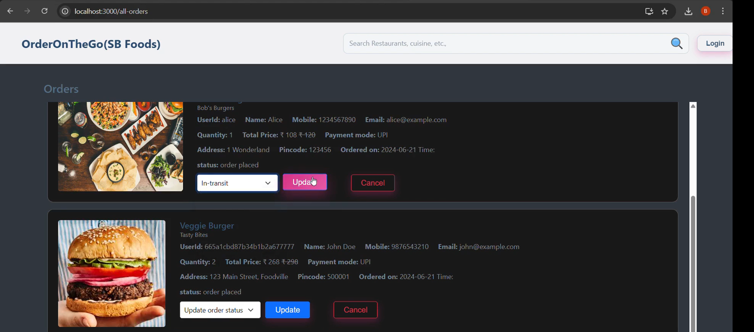

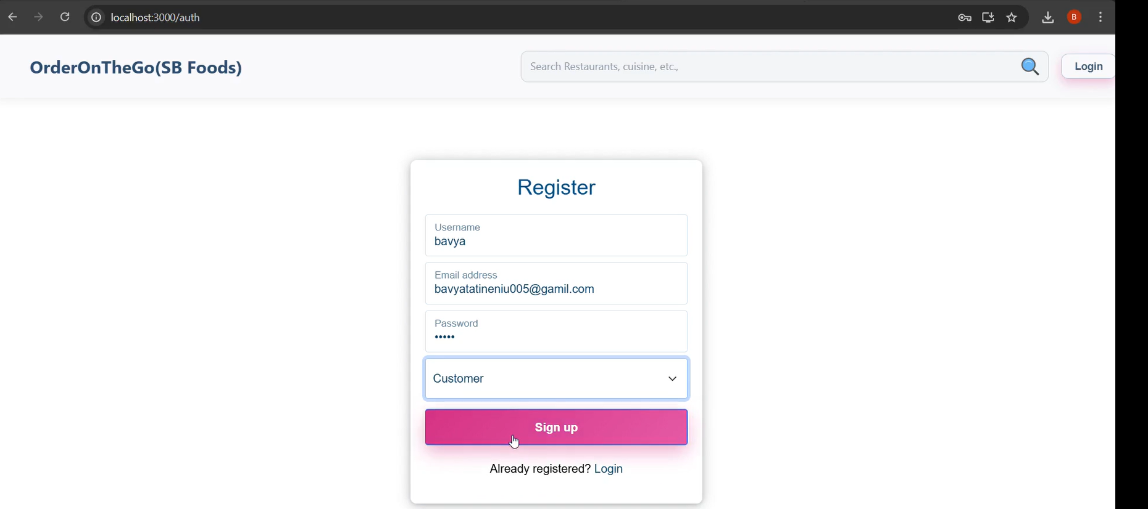

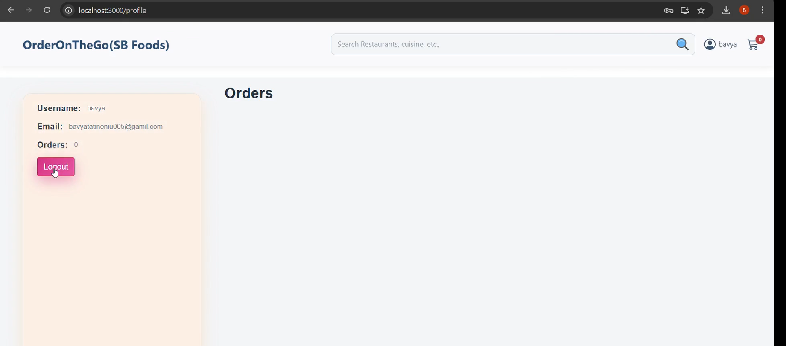

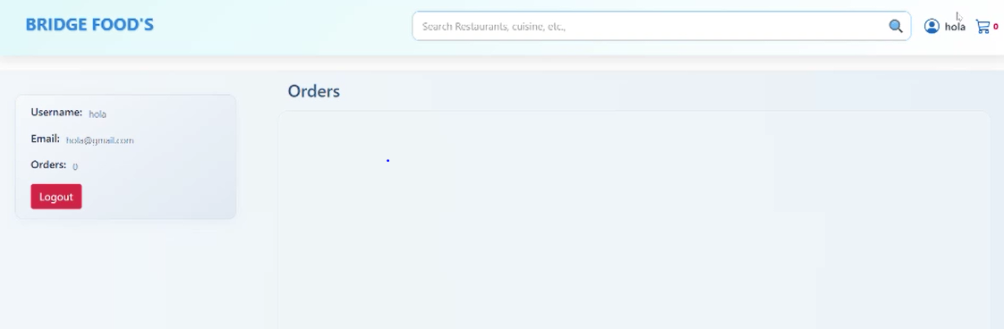

# Testing

* **Manual testing** was done by using the app (register, login, cart, order flow).
* **Postman** was used to test backend APIs.
* **Browser DevTools** helped inspect React components and API requests.

# Screenshots or Demo

<https://drive.google.com/drive/folders/1OOS9KjxfeMRJcuTkFtbiu0xEAoSQyVV1?usp=sharing>

**12 . Known Issues**

* Lack of Authentication Tokens: The login system does not implement JWT (JSON Web Tokens) or session-based authentication, resulting in less secure user sessions.
* No Order History Feature: Users are currently unable to view a history of their past orders after placing them.
* Cart Volatility: The shopping cart is stored in the browser’s localStorage, which means it resets when the user logs out or clears browser data.
* Absence of Automated Testing: The application lacks automated testing frameworks; all testing is performed manually.
* No Real-Time Order Updates: Changes made by the admin, such as order status updates, are not reflected in real-time on the user interface.

**13. Future Enhancements**

* Frontend Testing with Jest: Integrate the Jest testing framework to automate unit and component testing for frontend code.
* Backend API Testing with Supertest: Implement Supertest for comprehensive backend API testing.
* Payment Gateway Integration: Add secure payment processing using platforms such as Razorpay or Stripe.
* Role-Based Admin Access: Introduce role-based access control (RBAC) to manage admin permissions and enhance backend security.